Wave Propagation

Aircraft Carrier Cable System

Team:

Carpe Noctem

Team Leaders:

Jake Tisdale

Team Members:

Carlos Lazo, Christopher Rappa, Jake Tisdale, Michael Sangillo

Course: TDC1 – Wave Propagation

Instructor: Michael Richman

Group Hours: 30 hours

Date Submitted: 11/10/08

Introduction
We have been assigned to examine a specific section of a cable located on an aircraft carrier. This section is located where two cables with different diameter are joined. Each cable is connected to a vibrating beam. This section is of special interest because this change in diameter causes the vibration waves traveling through the cable to reflect and transmit different portion of there energy at this intersection. This setup can be seen in Figure 1.
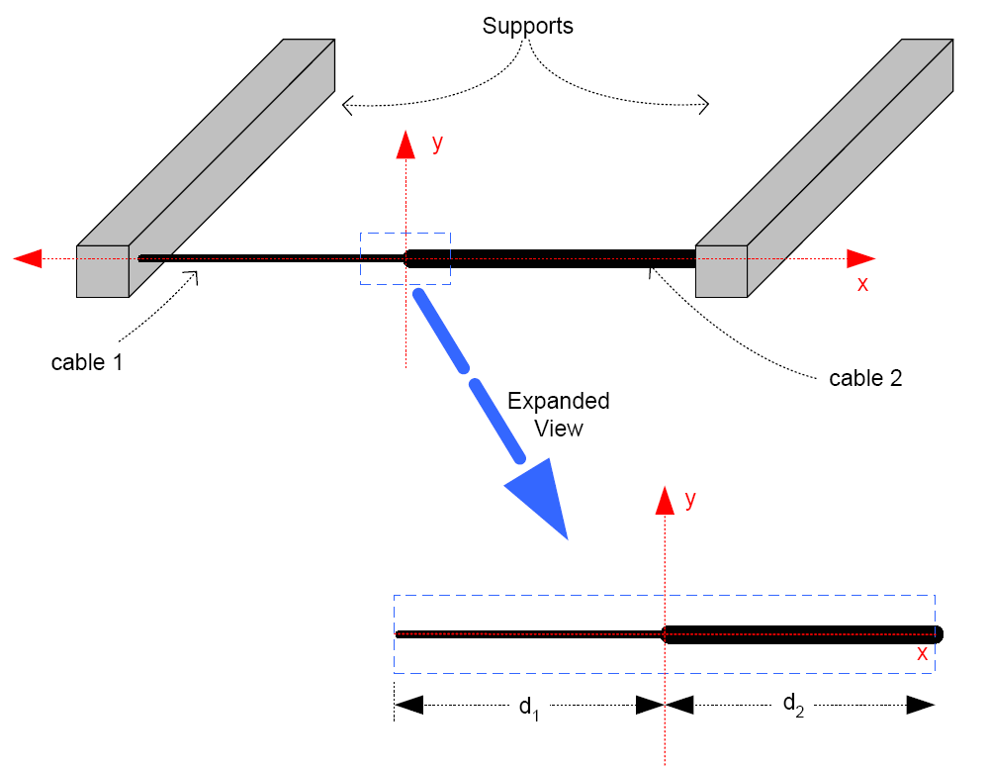
Figure 1: Cable Setup

The group will look at 3 different conditions that could be applied to this cable. The first will assume that both cable 1 and cable 2 have the same properties and that the vibration waves coming from each end have the same amplitude and wavelength. The second condition assumes the customer will implement a costly solution to prevent any vibration from coming cable 2. In this condition the cables do not have the same properties.
The final condition assumes the damper is too expensive and the vibration again comes from both sides and the cables do not have the same properties.

Generic Algebra

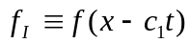
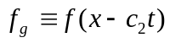
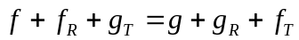

1a)
x=0 sense looking at point x=0
1b)

2a)
Slope as lim f=0 and lim g=0 is the same
2b)

4 equation 4 unknowns (1b+2b)

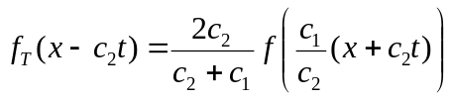
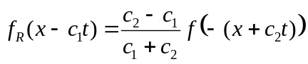
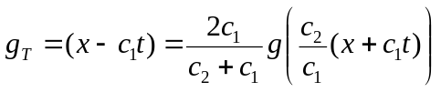
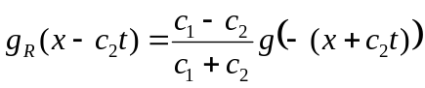

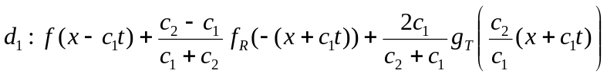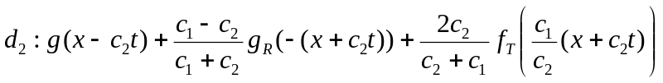

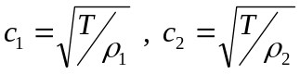

Equation 1

Condition 1
The vibration coming from each beam is equal (g(z)=f(z)) and give by the customer as in Equation 1. Also the value of common “c” terms can be seen in Table 1. The tension (T) is know to be 1N, and further the linear mass densities are gives as 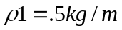 and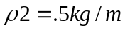.

 | C1 | C2 | (C2-C1) (C1+C2) | (C1-C2) (C1+C2) | 2*C2  (C1+C2) | 2*C1  (C1+C2)
Condition 1 | 1.414 | 1.414 | 0.000 | 0.000 | 1.000 | 2.000
Condition 2 | 1.414 | 0.707 | -0.333 | 0.333 | 0.667 | 7.567
Condition 3 | 1.414 | 0.707 | -0.333 | 0.333 | 0.667 | 7.567
Table 1: Common “c” term values for condition

Using the generic setup for d₁ and d₂ and inserting the “c” terms for condition 1 the ?. Also the 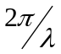term is known as the Wave Number (K).
1
1
0
0
1
1

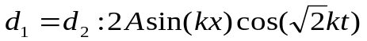

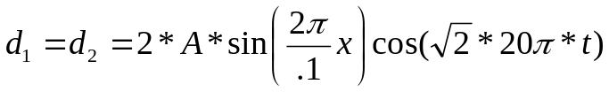

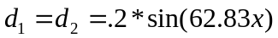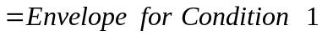
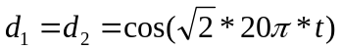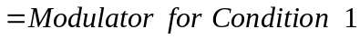

Condition 2
The vibration coming from the left beam is give by the customer as in Equation 1. Also the value of common “c” terms can be seen in Table 1. The right beam is fixed with a damper and the vibration is eliminated on the right side (g(z)=0). The tension (T) is know to be 1N, and further the linear mass densities are gives as and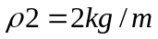.
Using the generic setup for d₁ and d₂ and inserting the “c” terms for condition 1 the ?. Remember that for this condition the g(z)=0, so there is no g_{R}, g_{T} or g.

0
0
0

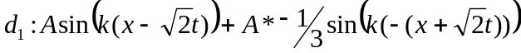
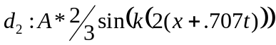

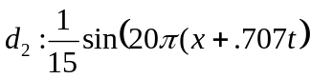
With Condition 2 there is no source on the right side. This means the only acting wave in d₂ is the f_{T}. Therefore there is no standing wave in d₂. The next step is to find the envelope for the standing wave in d₁.
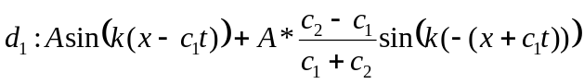
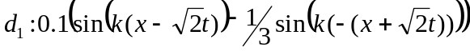
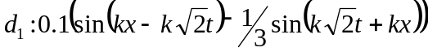
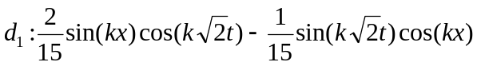
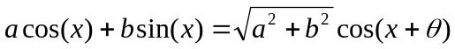
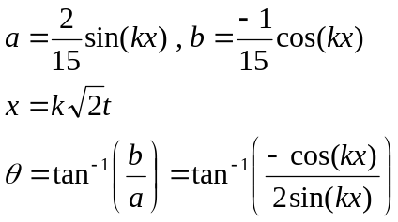
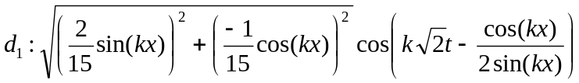
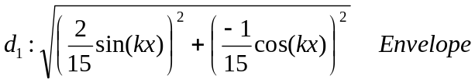
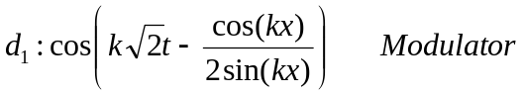

Condition 3
This condition looks at the scenario of Condition 2 being too expensive and the vibrations again coming from both sides. The vibrations are equal (g(z)=f(z)) and give by the customer as in Equation 1. Also the value of common “c” terms can be seen in Table 1. The tension (T) is know to be 1N, and further the linear mass densities are gives as and.

Find ρ₂ for Condition 2
In this section the group was asked to find RHO₂ for d₂ so that the transmitted wave length is 1 meters. 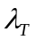is equal to the inverse space frequency. This was done as follows.

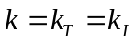
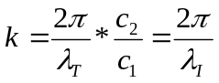
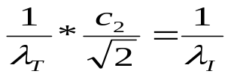
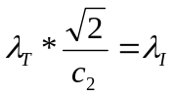
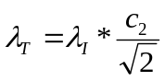
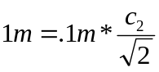
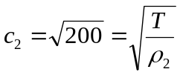
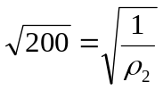
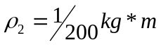

BAD
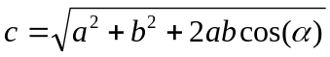
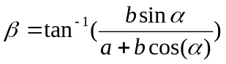
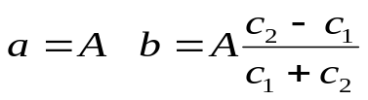
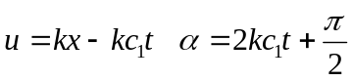
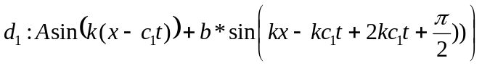
1
